**Global Economic and Demographic Trends Analysis:**

**Project Overview:**

The objective of this project is to analyse and derive insights from global data covering population, GDP, country characteristics, and health-related indicators.

**Data sources:**

* + Excel Files (Population Per Country, Meta Data, GDP by Country 1960-2016 files)
  + SQL Database (Countries World file)

**Data Cleaning & Transformation:**

Imported data files into Power BI.cleaned the data set by handling null values, removing blanks and standardizing the data types appropriately. Ensured the data is consistent and structured for analysis. Merged and related the tables based on common fields.

**Statistical Analysis:**

* Performed basic statistical analysis for population data across countries.
* Calculated average GDP percapita by country and region
* Identified countries with highest and lowest GDP
* Analyzed the distribution of IMR across countries
* Calculated the range and standard deviation for infant mortality.
* Calculated average literacy rate across regions and countries
* Analyzed the growth trends for key variables population and GDP.

**DAX CALCULATION:**

Calculated the population growth rate over time.

Calculated the GDP growth rate.

Created calculated columns for GDP per capita.

Aggregated population or GDP data by region.

Derived insights such as the correlation between literacy rates and GDP.

DASHBOARD:

I streamlined my analysis into 2 parts. I analysed economic and demographic trends and parameters and made 2 dashboard

World Economic Trends Analysis:

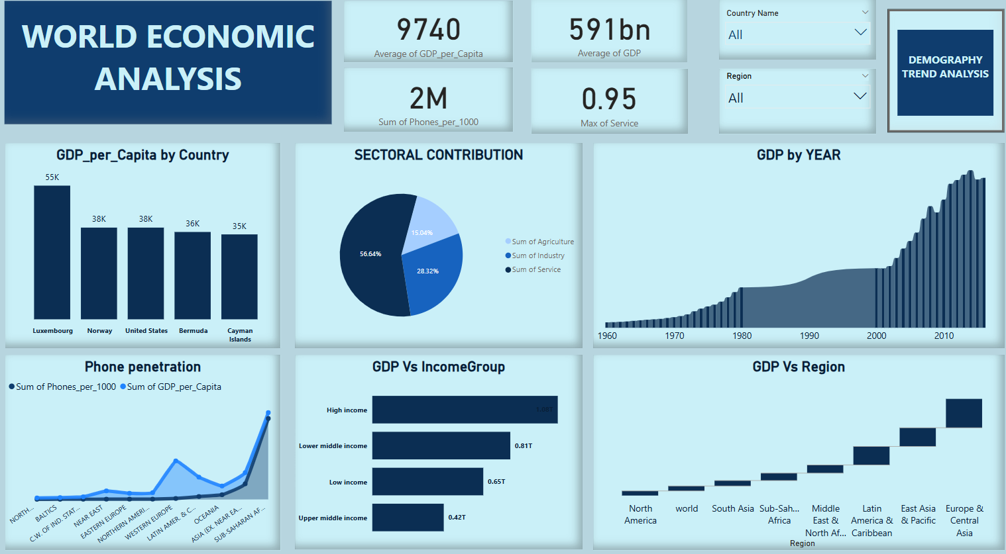

World Demographic Trends Analysis:

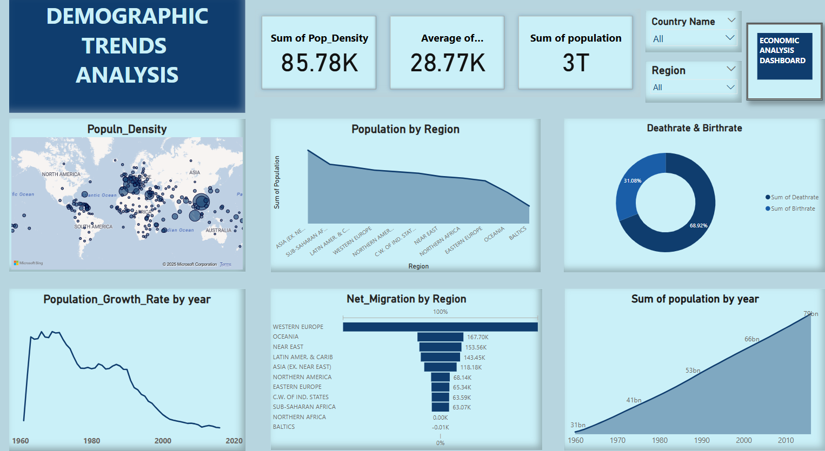

Report :

Made the report for the above shown dashboards in PowerBI and attached the repective reports below. 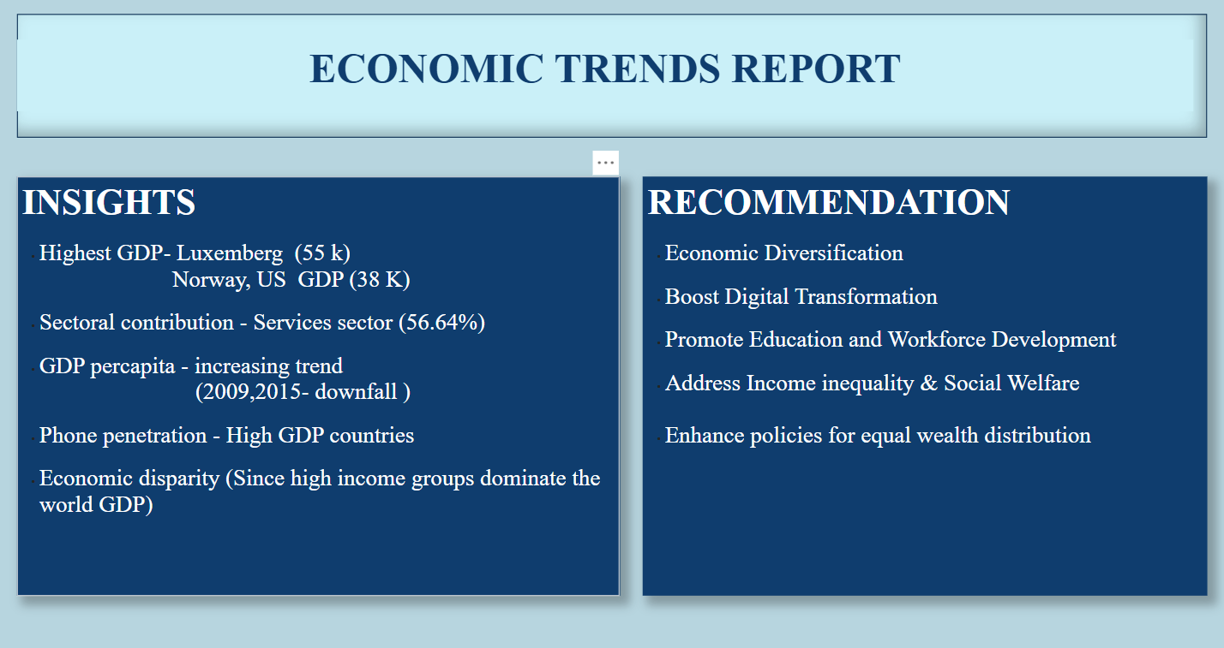

**Demographic Trends report:**

